Worksheet No. – 05

Aim/Overview of the practical: Implementation of report in Tableau.
Objective: To implement and design interactive reports in Tableau by connecting to datasets, performing data visualization, and creating charts, graphs, and dashboards to analyze data effectively. The objective is to present meaningful insights through visual representations that support better understanding and data-driven decision-making.

PROCEDURE
Step 1: Open Tableau
Launch Tableau Desktop or Tableau Public on your computer.

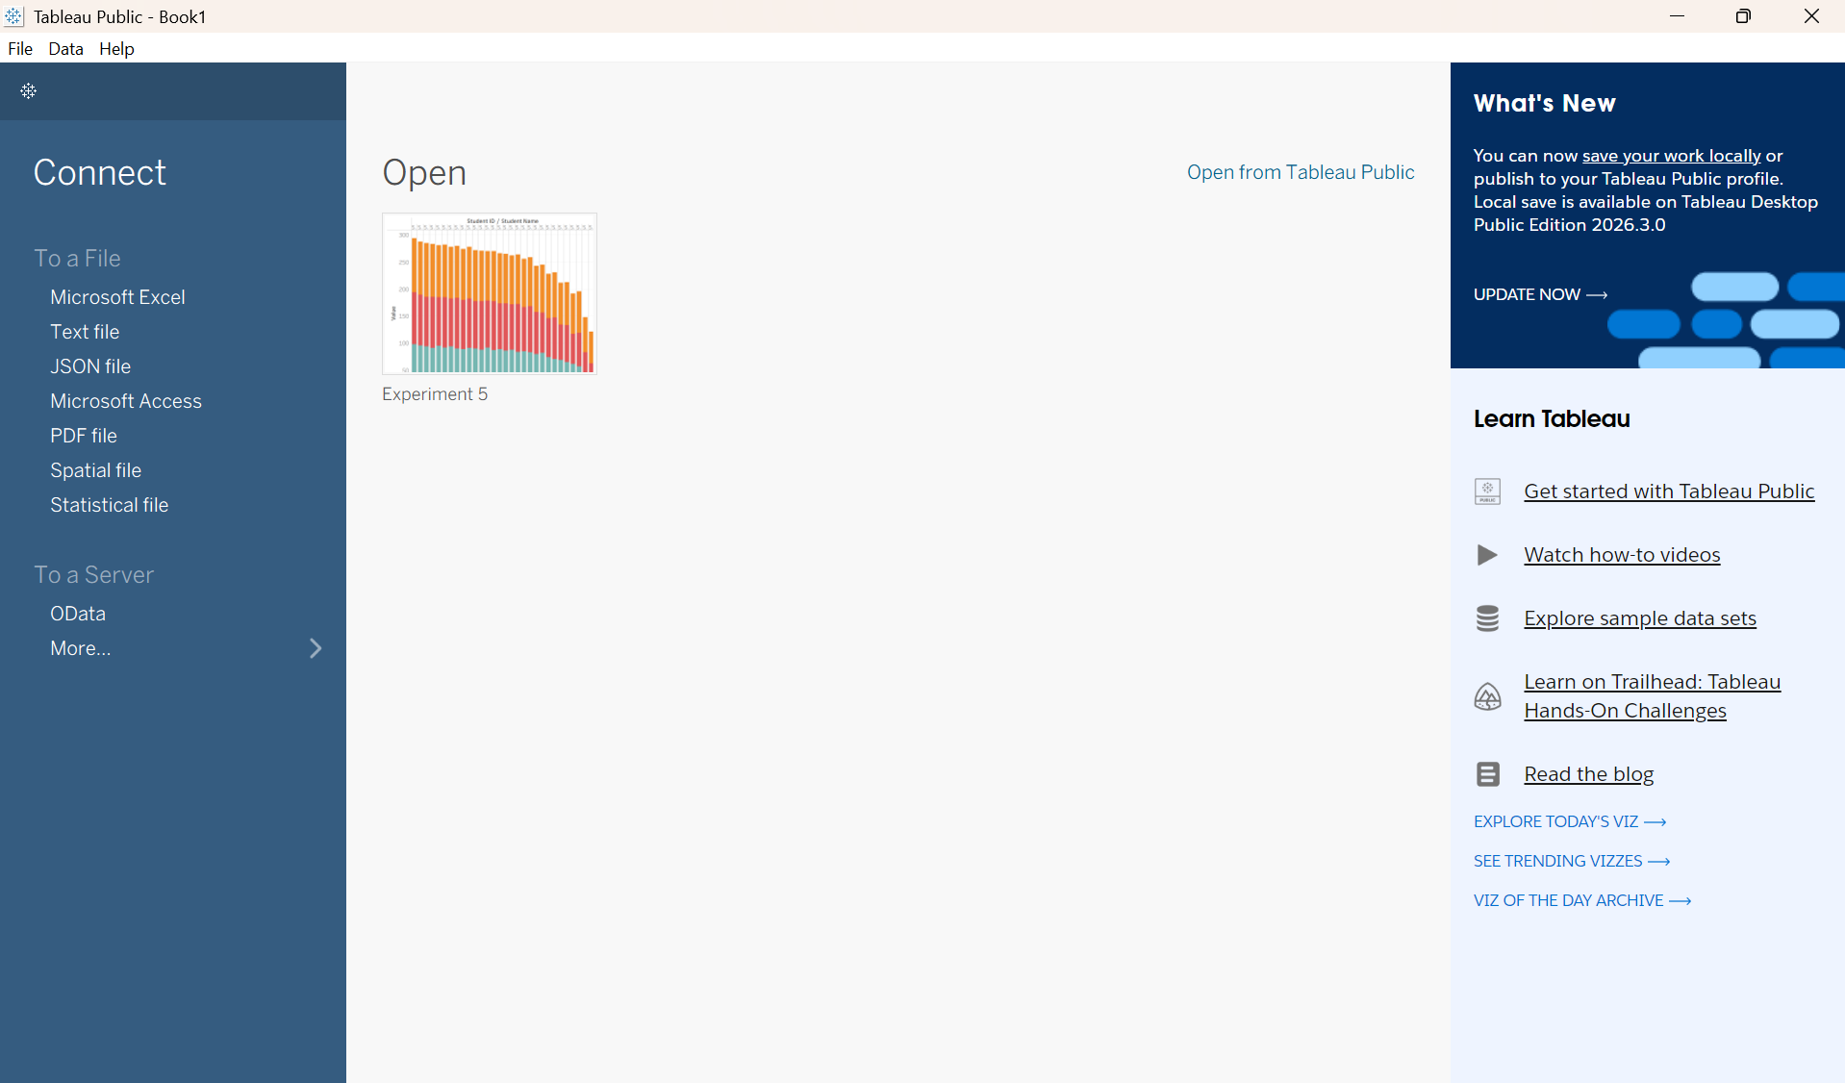
Step 2: Connect to a dataset
Select Microsoft Excel or Text File under Connect. Browse and open your dataset.

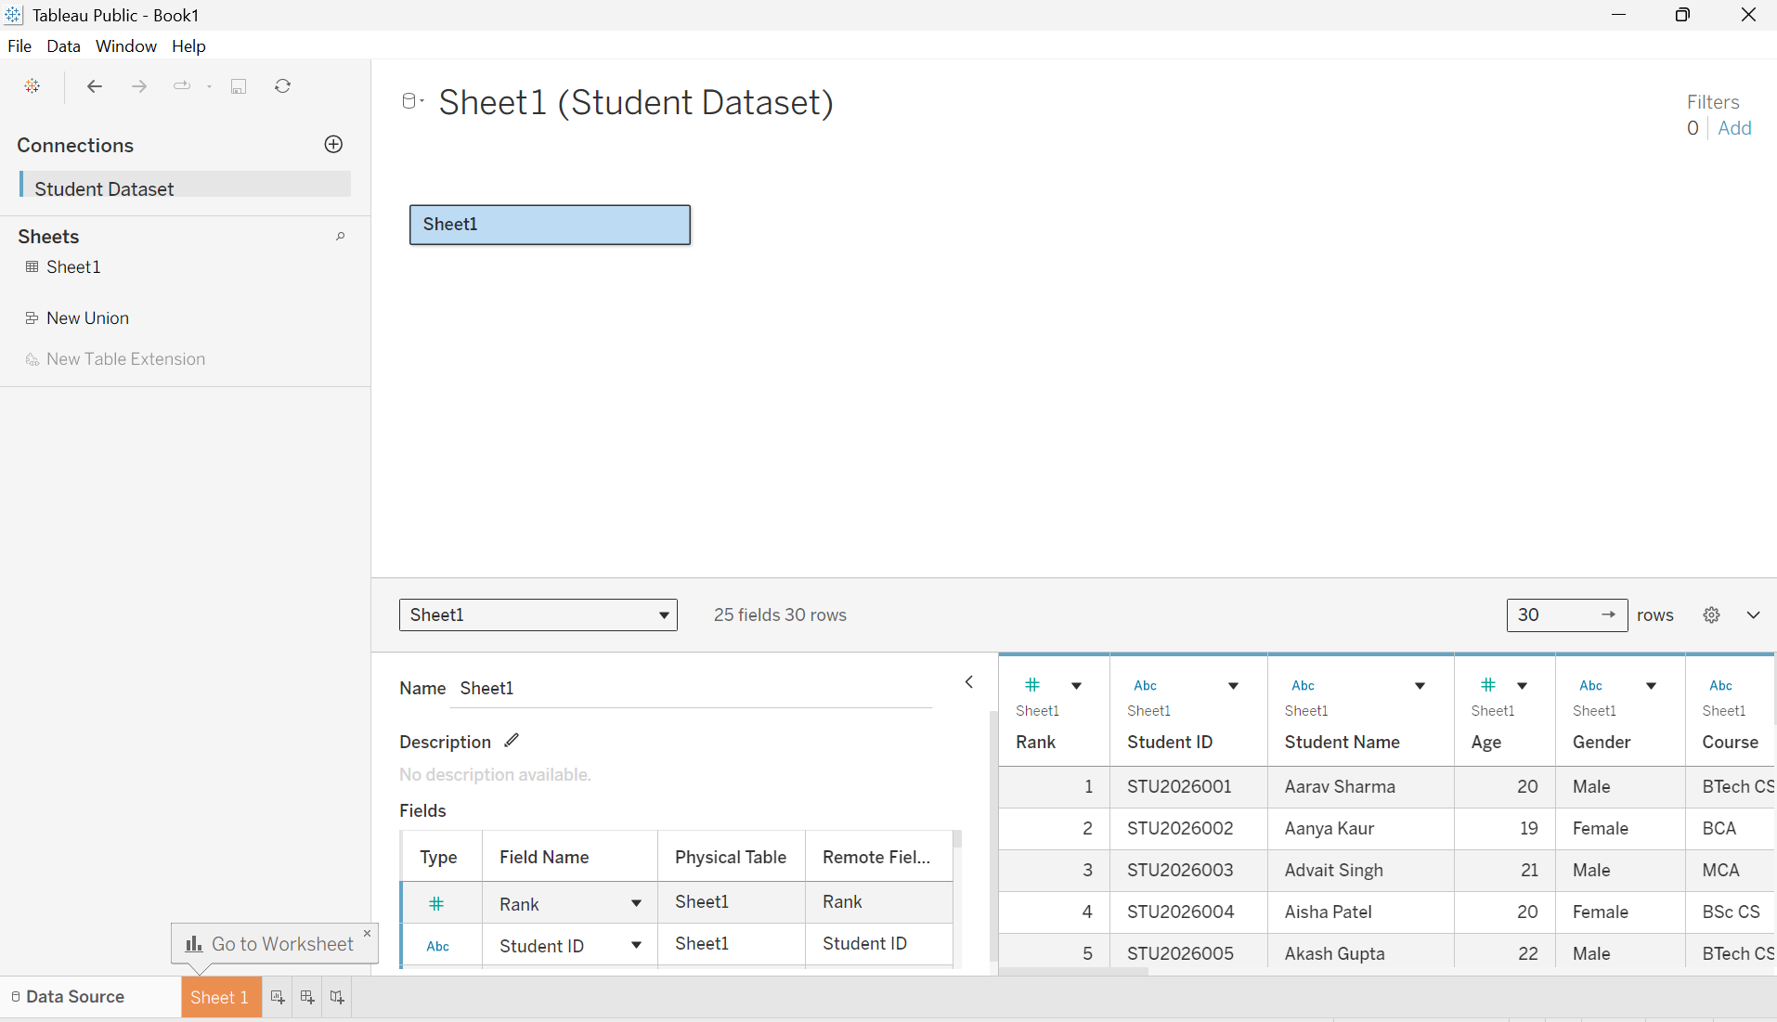

Step 3: Prepare the data
Check the column names, data types, and data preview in the Data Source tab.

Step 4: Create a worksheet
Click Sheet 1 at the bottom of the screen to begin creating a report.

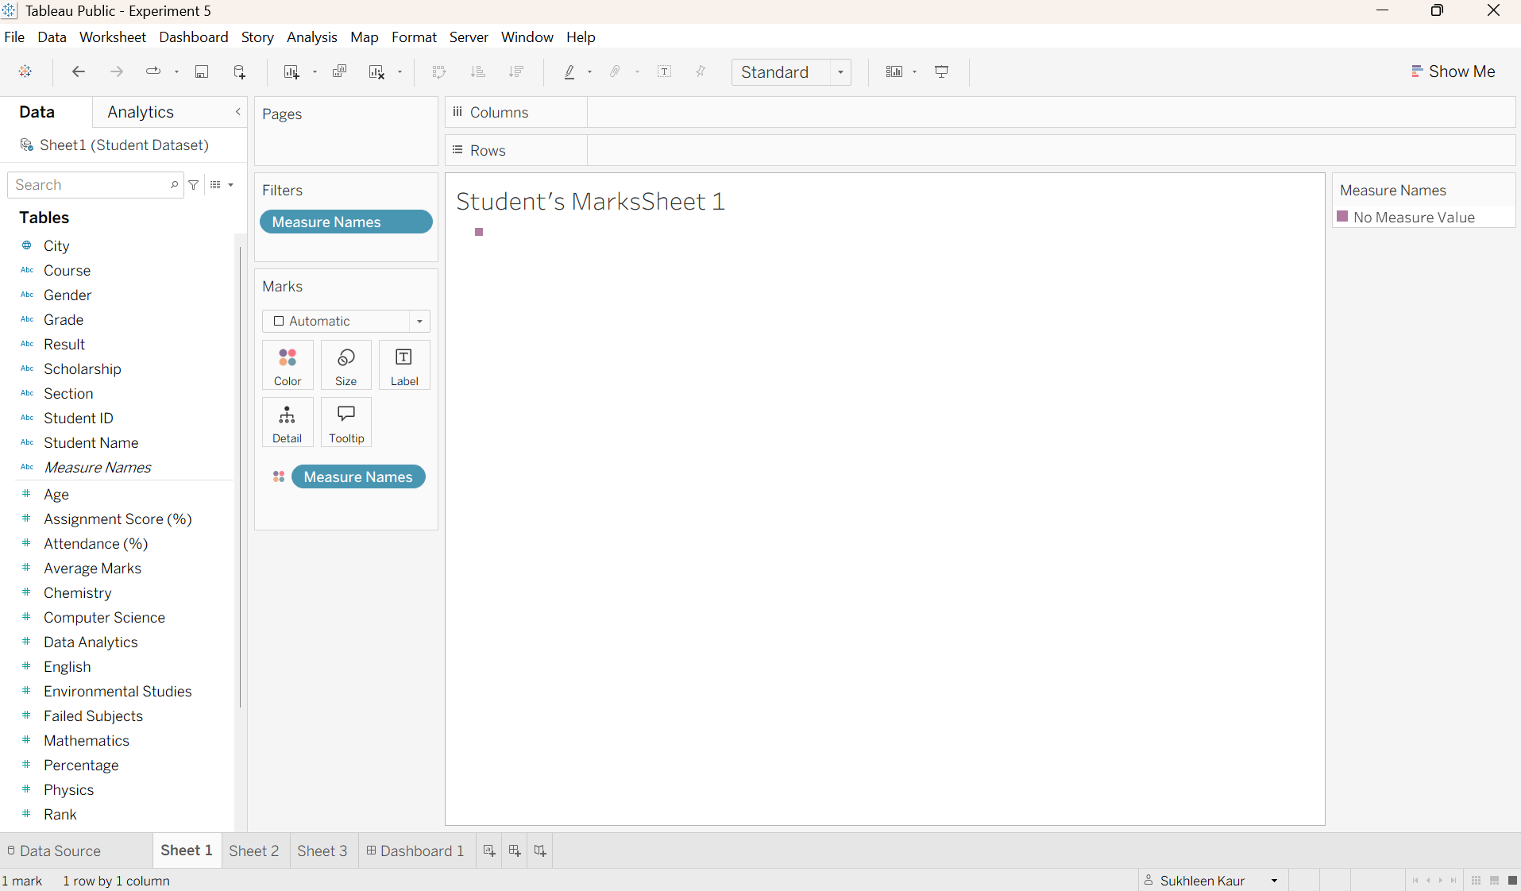
Step 5: Create a chart
Drag the required fields from the Data pane to the Rows and Columns shelves. For example, drag Student name to Columns and Marks to Rows to create a bar chart.

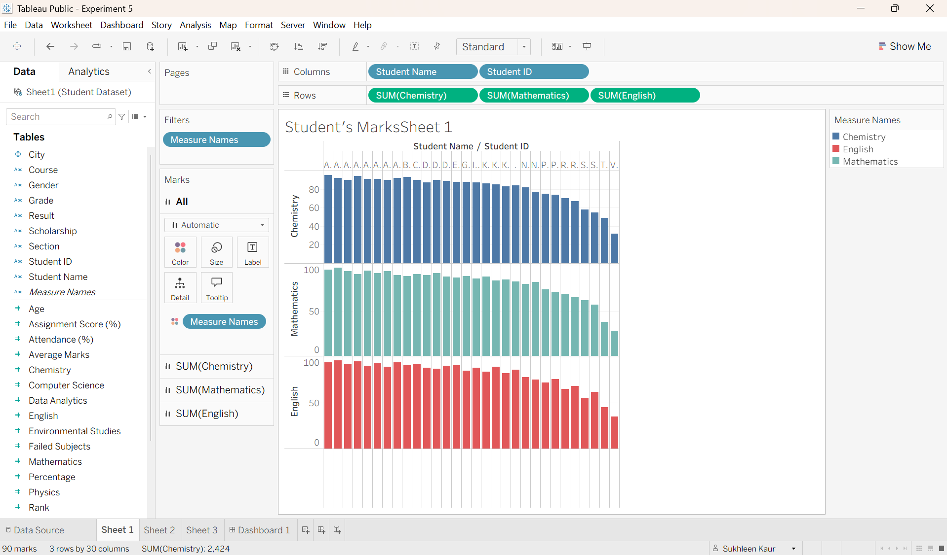
Step 6: Select a visualization
Click the Show Me panel and select a suitable visualization, such as a bar chart, line chart, or pie chart, according to the dataset.
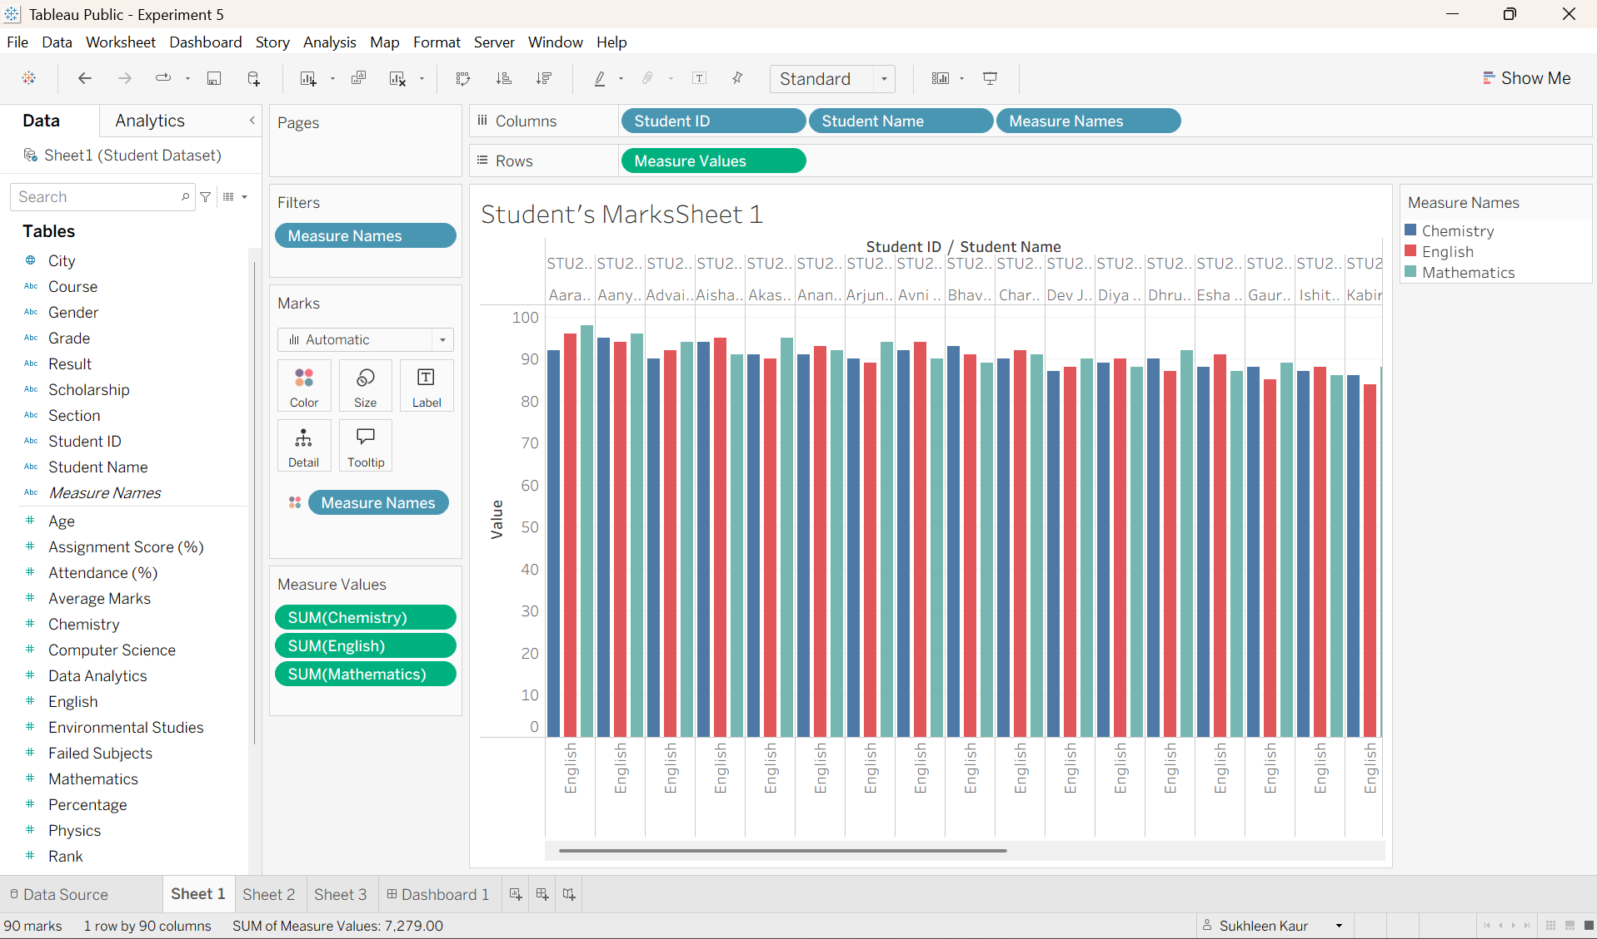
Step 7: Create the 2nd chart
Drag the required fields from the Data pane to the Rows and Columns shelves. For example, drag Student name to Columns and Marks to Rows to create a bar chart.
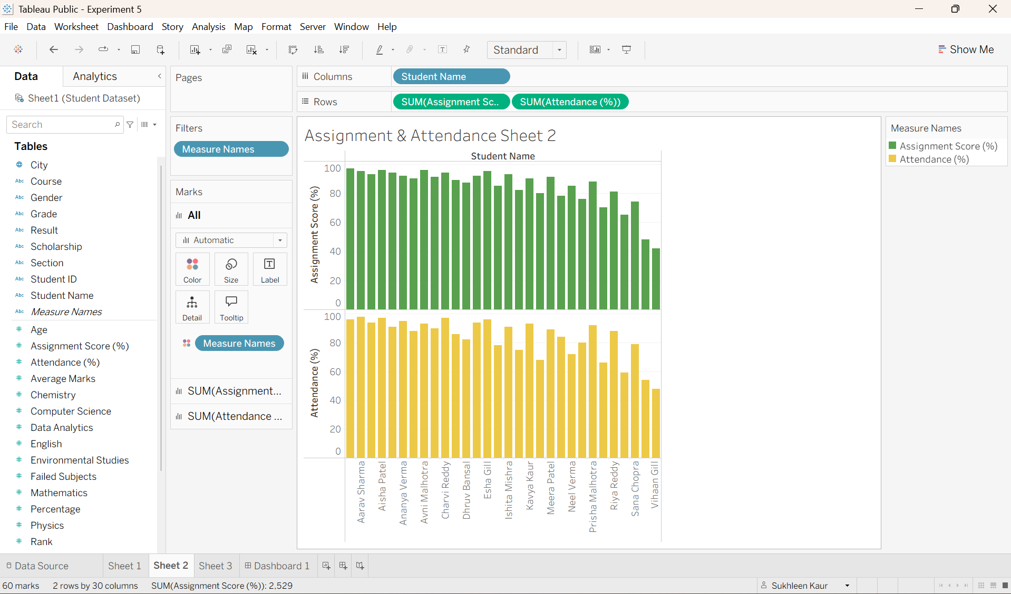

Step 8: Select a visualization
Click the Show Me panel and select a suitable visualization, such as a bar chart, line chart, or pie chart, according to the dataset.
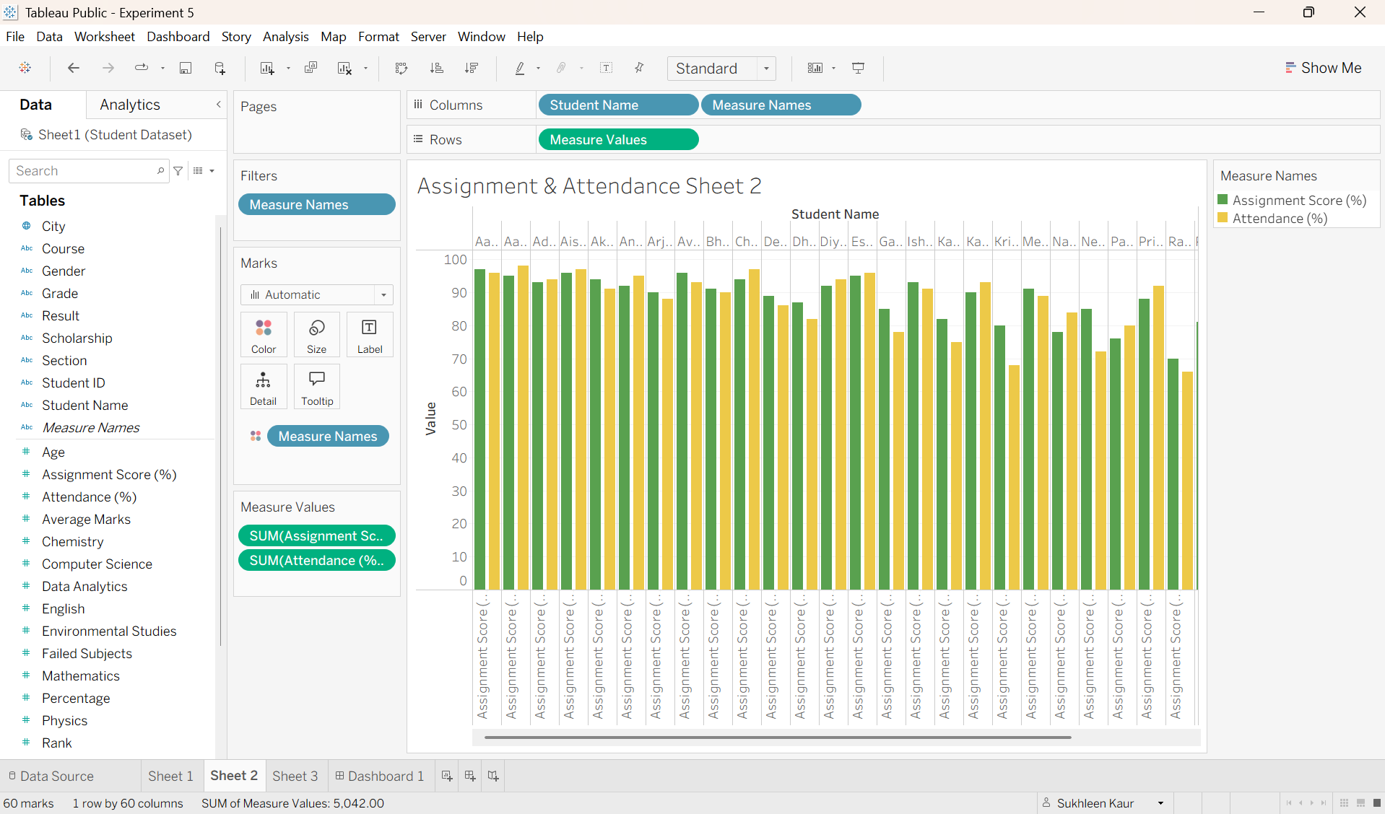
Step 9: Create the 3rd chart
Drag the required fields from the Data pane to the Rows and Columns shelves. For example, drag Student name to Columns and Marks to Rows to create a bar chart.
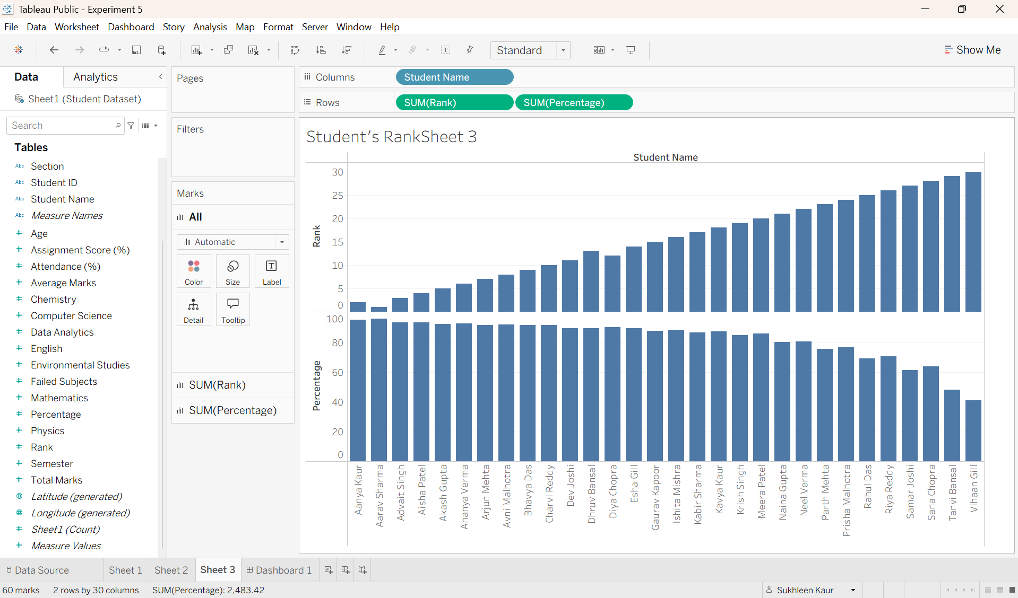
Step 10: Select a visualization
Click the Show Me panel and select a suitable visualization, such as a bar chart, line chart, or pie chart, according to the dataset.
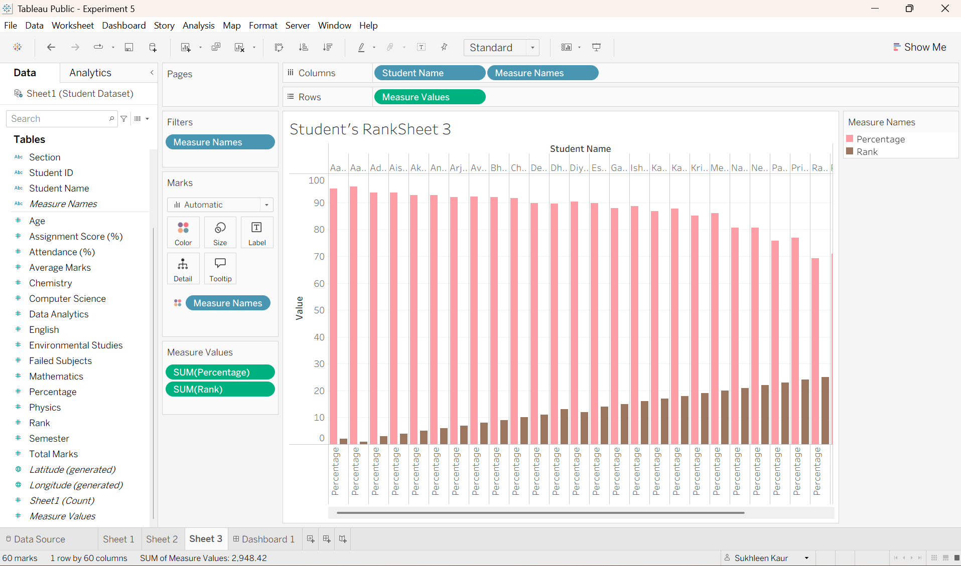
Learning Outcomes:
- Learned to connect datasets from different sources to Tableau for data analysis.
- Gained knowledge of data preparation and handling different data fields and types.
- Developed skills in creating charts, graphs, and visualizations using Tableau.
- Learned to format reports using titles, labels, colors, and legends.
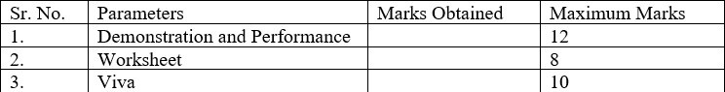
Evaluation Grid:

